* 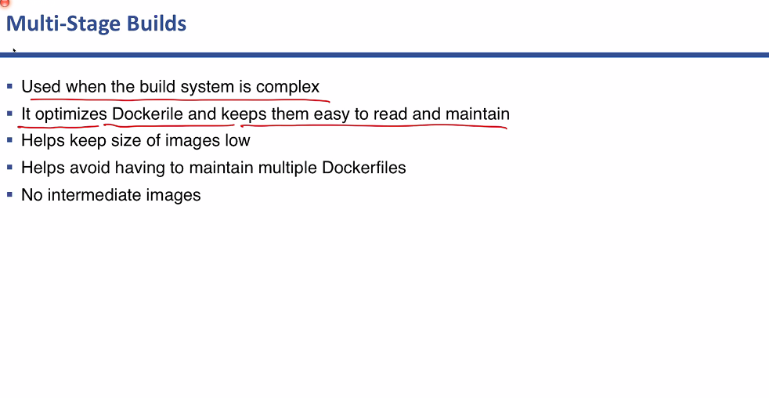
* Build stage convert the source code into an executable package.
* 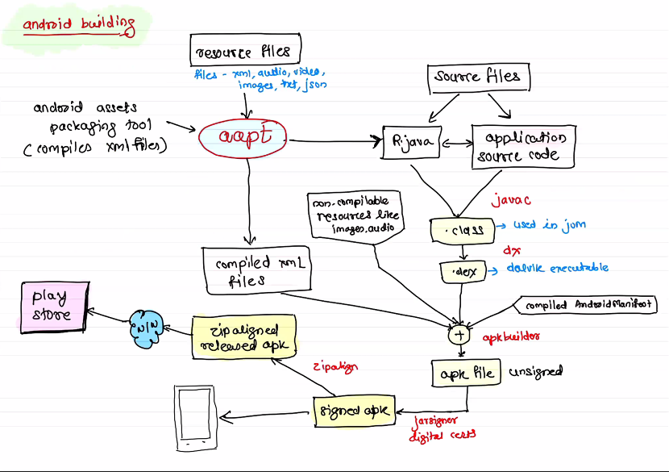
* 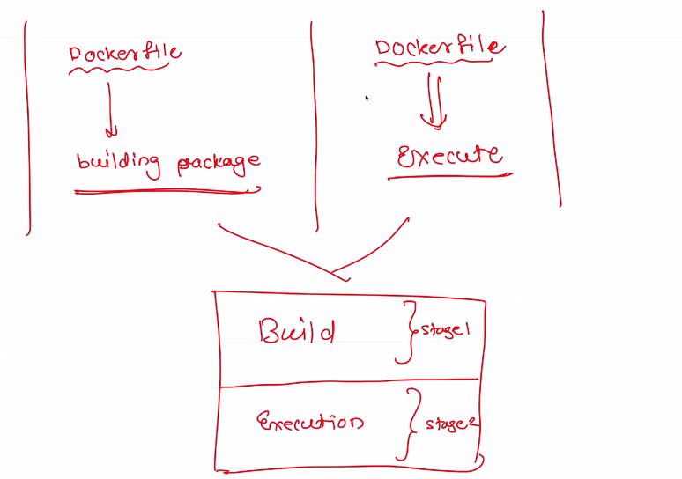
* 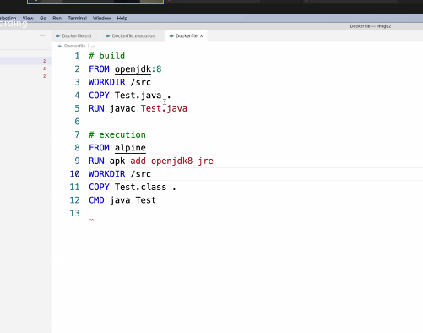
* > docker image pull openjdk:8
* > docker image build -t java-app .
* > docker container run -it --rm java-app
* > docker image prune
* > docker container run --rm -it --name app java-app-final
* so what's happening in backgroud, is docker deleting content of other stages after build, and then left only execution stage!
* 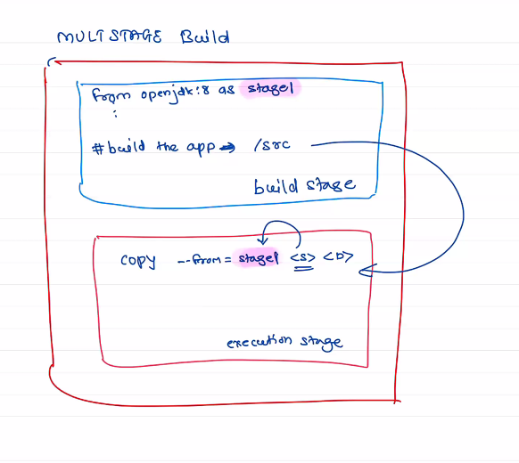
* 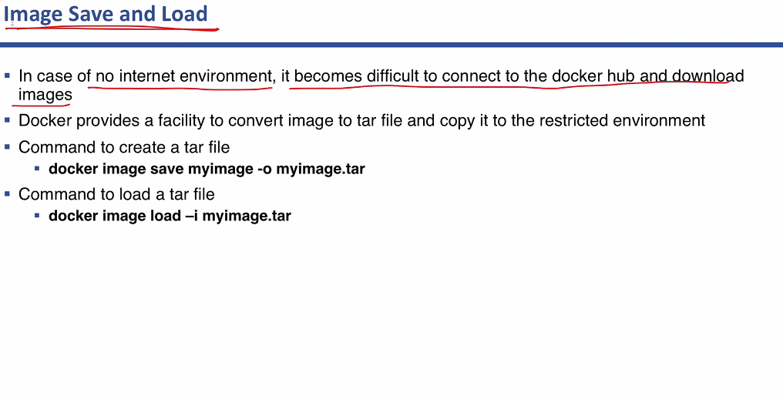
* Exam pointer